Review for Exam II (Chapter 3)
1. Exponential and Logarithmic Functions
- Compound interest and the constant e
- The natural exponential function
- The natural logarithmic function
- Exponential and logarithmic functions of base b
- Derivatives of exponential and logarithmic functions
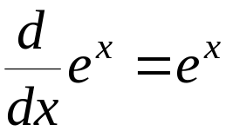 and 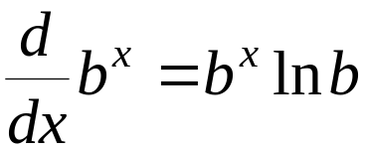
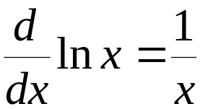 and 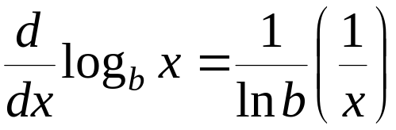
2. Three Rules of Differentiation
- Product Rule
If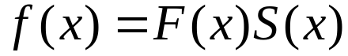, then

- Quotient Rule
If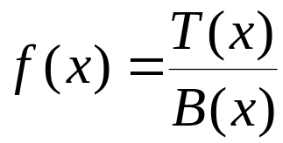, then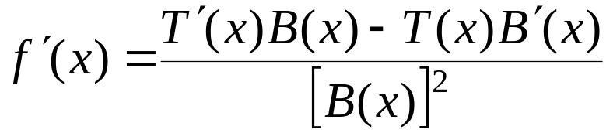
- Chain Rule
If 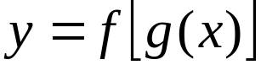, then 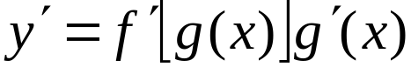
3. Implicit Differentiation
Two-step Procedure
- Differentiate both sides of the equation, regarding y as a function of x, and apply the Chain Rule, so we have 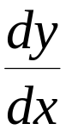 whenever we touch the variable y.
- Solve it for , and substitute the given point 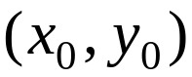 if required.
4. Related Rates
Use the six-step procedure on Page 221 and implicit differentiation.
5. Review Exercises
Example 1. Find 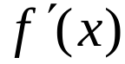.
(1). 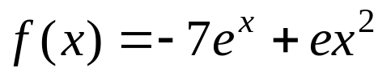 (2). 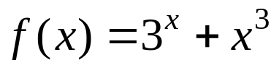 (3). 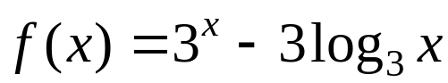
Example 2. Find .
(1) 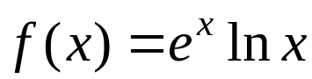 (2)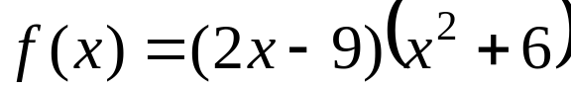 (3)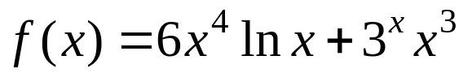
Example 3. Find .
(1). 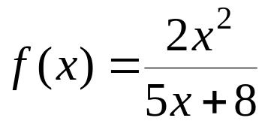 (2). 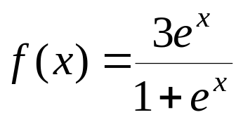 (3). 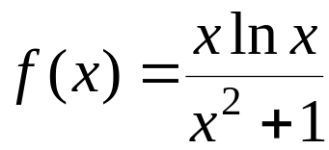
Example 4. Find .
(1). 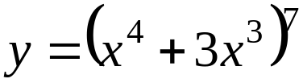 (2). 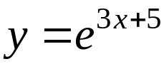 (3). 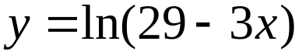
Example 5. Find .
(1). 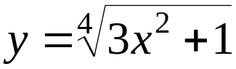 (2). 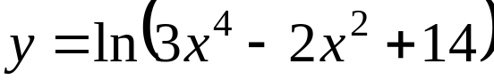 (3). 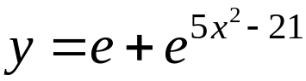
Example 6. Find .
(1). 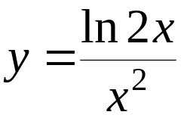 (2). 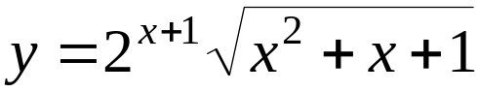 (3). 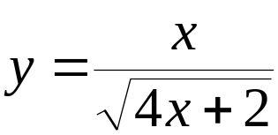
Example 7. Use implicit differentiation to find the slope of the line tangent at the indicated point.
(1) 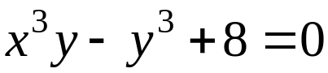, (-2,1) (2) 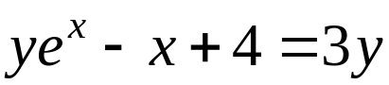, (0,2)
Example 8. Related Rates Problems (10 to review):
Page 224, 12, 14, 15, 17-18, 21-22, 25, 26, 27

6. A Summary: Formulas and Rules

Formulas:
(1). If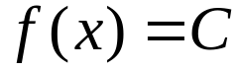, a constant, then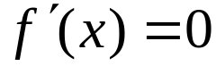, i.e. 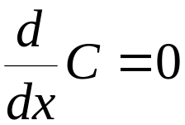.
(2). If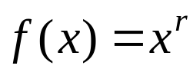, where r is a real number, then 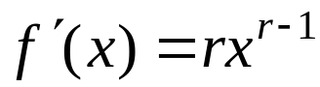
(3).
.
(4). and
(5). and

Rules:
(1). Constant Multiple Rule 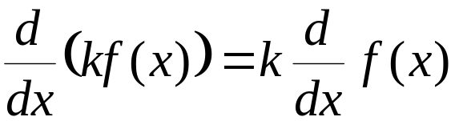
(2). Sun/Difference Rule 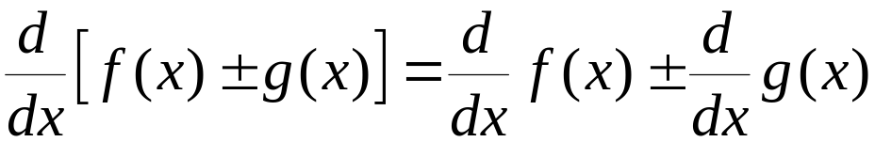
(3). Product Rule
If, then
(4). Quotient Rule
If, then
(5). Chain Rule
If , then

